Reynaldo Ortiz

CS-305-H7001 Software Security 23EW2

5-2 Coding Assignment: Certificate Generation

Certificate Authorities:

Certificate Authority (CA) is a tool that is utilized for online identity validations. The CA will allow a secure communication as well encrypted communication over the network. While doing as well confirming the authentication of sign documents by certifying that these documents had not been altered by any third party. CA has made possible to do banking, your taxes and shop by securing your transaction.

* certificate information

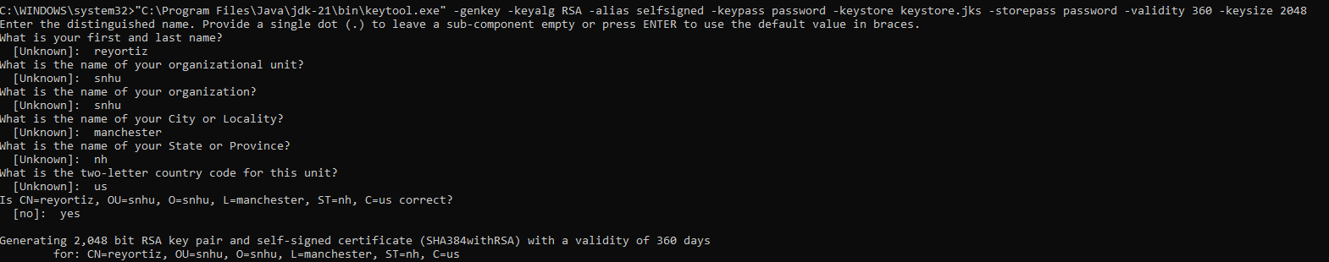

* certificate printout

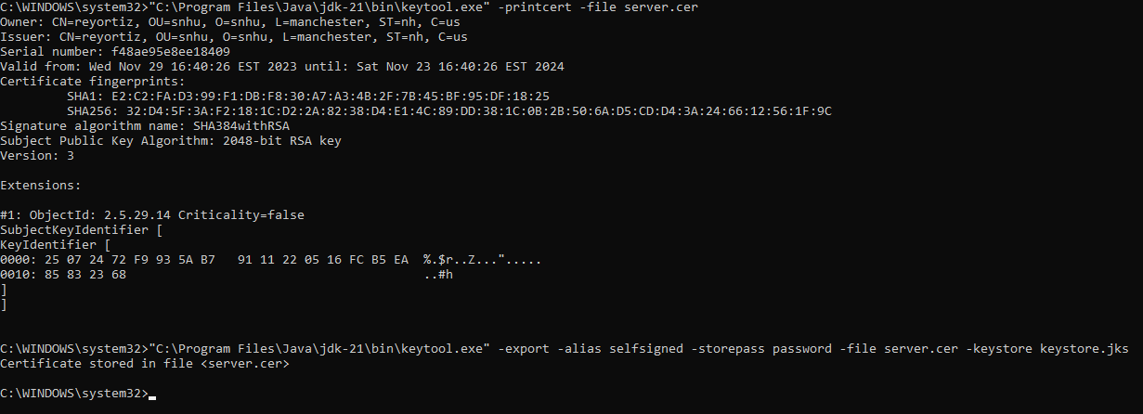

References:

*What is a Certificate Authority (CA) and functions of a Certificate Authority (CA)*. What is a certificate authority (CA) and functions of a Certificate Authority (CA). (n.d.). https://www.omnisecu.com/security/public-key-infrastructure/what-is-a-certificate-authority-ca.php

Team, SSL.com Support. “What Is a Certificate Authority (CA)?” *SSL.Com*, 9 Dec. 2021, www.ssl.com/faqs/what-is-a-certificate-authority/.